Key Catarina Information

Plays as a 10 or 2nd striker for OL but plays as a false 9 for USWNT

6 INT caps 4 goal contributions

20/6 in 31 appearances for OL

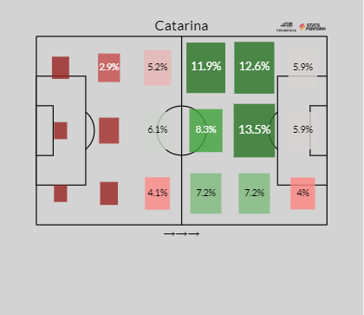

Consistent in the press, able to win the ball back in the attacking third

Similar playstyle to Roberto Firmino

Possible Replacements:

1. Alex Morgan

This option is the much safer option. Experienced, successful, in form, and reliable for club and nation. This choice however goes against the current swing on the team. The team is handing down the reins to some younger players on the roster. Alex Morgan offers more as a pure 9 and better suited for the attacking style of the USWNT compared to other possible candidates.(detailed stats soon)

1. Michelle Cooper

Checks all the boxes that catarina does a young, creative number 10 and/or false 9

Scored in Concacaf Women's U-20 Championship victory over mexico

Currently plays at Duke, 12 goals 5 assists in 18 games her freshman year